
One Tree Hill Cup

26 – 27 October 2019
Auckland Archery Club


In Both Matchplay Divisions

1st Place: $300
2nd Place: $200
3rd Place: $100

Proudly Sponsored By
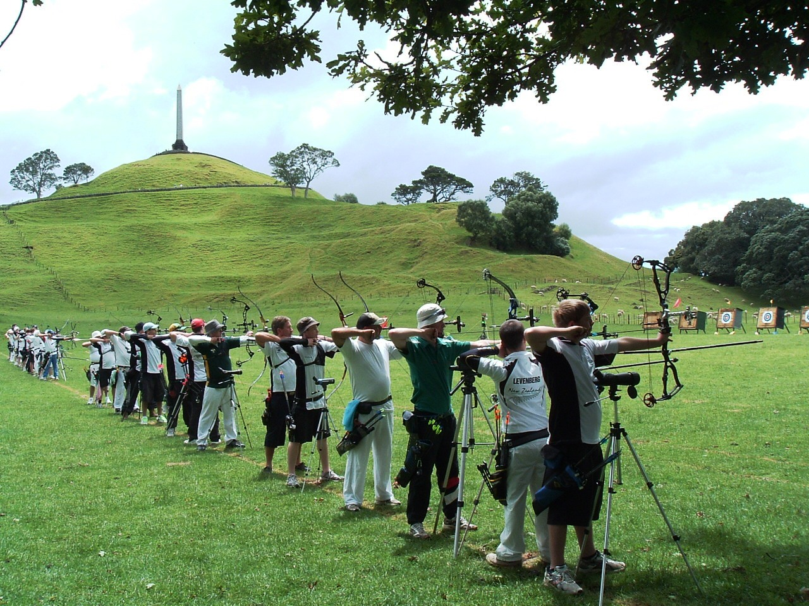


Shooting Programme:

Saturday 26th – Ranking Rounds

9:00am Recurve Bow Inspection
Note: A “camera shoot” competition will be held during the respective ranking rounds. To participate put $1 in the pot before the event begins. The first archer of the day to hit the ‘X’ marked in the centre of their target wins the prize!
9:30am First WA 72 Arrow Round (70m/50m, two 6-arrow sighting ends)
11:45-12:15 Lunch. A mini-compound clout fun shoot will be run during this time, with the prize of a Cartel mini-compound set-up for the winner.
12:30pm Second WA 72 Arrow Round (70m/50m, two 6-arrow sighting ends)
3:00pm Fun shoot (at conclusion of second ranking round)
The Iron Kiwi (Prize of $50 Archery Warehouse Voucher to the compound and recurve winners)
Please bring an old arrow that you don’t mind breaking (or plan to win!).

Sunday 27th – Match Play (Note: times are approximate – matches will continue immediately after the last match ends)

8:30am Compound Non-Elimination Match Play begins (50m, two 6-arrow sighting ends)
Note Free BBQ will be running over lunchtime!
~11:30am Recurve Non-Elimination Match Play begins (70m, two 6-arrow sighting ends)
~2:00pm Recurve Individual Medal Matches
~3:00pm Compound Individual Medal Matches
~4:15pm Presentation

Entry fee: $65
Entries to: ArcheryOSA or email me at carrowline@gmail.com
Cheques to be made out to ‘Auckland Archery Club Inc.’, or Bank Account 12-3089-0332100-00, ASB Highland Park Branch, please state OTHC and Surname in reference fields.
Entries close: 20th October or before if line is full. Fee with entry please. No payment accepted on the day.
Entries limited to 16 in each division for matchplay. Early entries have priority.
Uniform: Please refer to the ANZ dress code

ONE TREE HILL CUP ENTRY FORM

Name: ______________________________________ Club: _________________________ ANZ/Intl. No: ________

Address: __________________________________________________________________________________________

Email: _____________________________________________________________ Phone: _______________________

Division: □WA 70m (Open Recurve) / □WA 50m (Open Compound)
□Paid online ($65)

Please advise the tournament organisers (in
Confidence) you have any medical condition
e.g. allergies) or require assistance to score,
that they should be aware of.

